**Workshop 1: Using The DavidRumsey.com Georeferencer V4**

**Prerequisites**

* Account with georeferencer.com
* No SUNetID necessary

**1 - What is georeferencing?**

When you *georeference* a map, you are defining what locations on your map image correspond with places on the globe (represented by a modern digital base map). A common method of georeferencing involves defining “control points” that connect a location in the map image with where that point “truly” lies in the modern world.

DavidRumsey.com features an interface that supports crowd-sourced georeferencing of images in the collection. When you georeference a map, any site visitor can then view that image overlaid on Earth in the location you’ve placed it. Additionally, if a user later spies errors in the georectification of a map, they can edit the control points themselves, and the image is automatically re-registered in the proper location for all subsequent viewers.

**2 - How do I know if a map on DavidRumsey.com is georeferenced, and how can I view it?**

When viewing a map record on DavidRumsey.com (such as [this one](https://www.davidrumsey.com/luna/servlet/detail/RUMSEY~8~1~239938~5512085:U-S--Coast-Survey--City-Of-San-Fran?sort=Pub_List_No_InitialSort%2CPub_Date%2CPub_List_No%2CSeries_No&qvq=q:san%2Bfrancisco%2B1859;sort:Pub_List_No_InitialSort%2CPub_Date%2CPub_List_No%2CSeries_No;lc:RUMSEY~8~1&mi=0&trs=12)) in the LUNA Viewer, an orange button will appear that reads “View in Georeferencer” will appear in the top window. Click “View in Georeferencer” if you wish to view this map in its current georeferenced location, overlaid on a modern basemap.

If the orange button instead reads “Georeference This Map,” this indicates that the map is not yet georeferenced, but it can be. Clicking “Georeference This Map” will launch the Georeferencer site and allow you to georeference the image yourself.

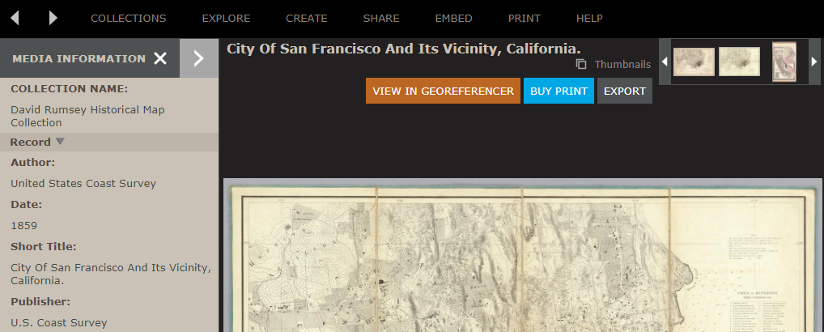

After clicking “View in Georeferencer,” a new window will appear with the URL “davidrumsey.georeferencer.com”. If a “Help” dialog box appears, click the check mark to close out it. You can zoom in, zoom out, and pan around the map image with the mouse. Change the transparency of the georeferenced layer with the slider at the top-right corner.

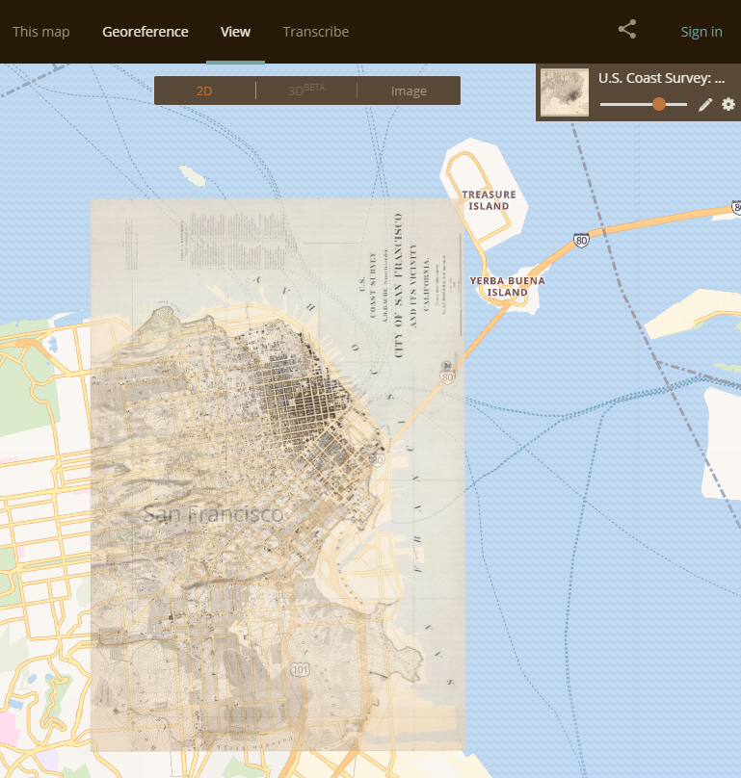

**3 - How do I georeference a map?**

*Note: You will need an account with georeferencer.com in order to save your georeferencing edits. Attempting to open a map in the Georeferencer will prompt you to create an account or sign in to an existing one; follow the instructions on the screen.*

First, open a map in the Georeferencer interface. You have a few options here:

* Option 1: Georeference a map from Scratch Using the “Search the Collection” bar on DavidRumsey.com to search by keyword, find a map in the LUNA search results that has *not* been georeferenced. Click “Georeference This Map” to launch the the georeferencing interface.
* Option 2: Fix Existing Georeferencing Work Find a map using LUNA search that *has* already been georeferenced and click “View in Georeferencer” to launch the map in View Mode. If you wish to fix or improve the alignment that a previous user has saved, click the “Georeference” link in the top header of the window (located next to the word View). 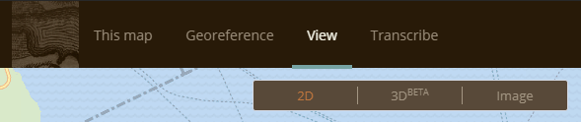A pop-up may appear stating that this map is “finished”; click “Continue georeferencing this map anyway” if you wish to do so.
* Option 3: Pick a Map at Random Use the Random Map link (<https://davidrumsey.georeferencer.com/random>) to be taken to a random map in the collection that has not been georeferenced or has insufficient georeference information.

After launching the Georeference interface, you’ll see a side-by-side view of a modern basemap on the left, and a copy of your map image on the right. Use the scroll wheel to zoom in and out of each map independently, and click-and-drag within each map frame to pan around.

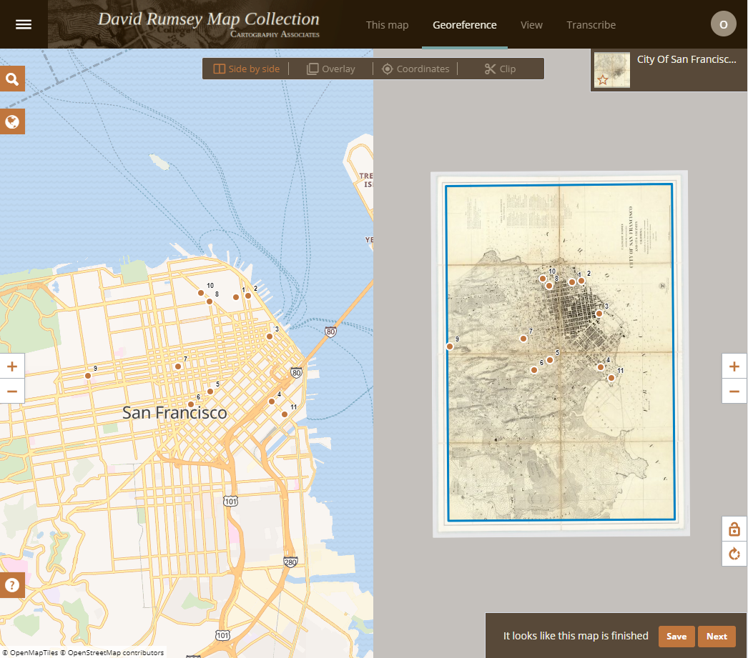

*Side by Side view. In this example, existing control points appear as corresponding numbered red dots over both images.*

To georeference a map, we recommend **first creating control points in Side by Side view, then checking your accuracy and fine-tuning your control points in Overlay view**.

*3.1 - Macro-scale edits in Side by Side View*

* Find a distinct location that appears in both the old and modern map.
* Click on a control location on the old map. Then click on the same geographic location in the modern map. Two orange “magnifying glasses” containing crosshairs will appear, one above each point you selected on the old and modern map. *Note: In side-by-side view, it does not matter on which map you place the first point.*

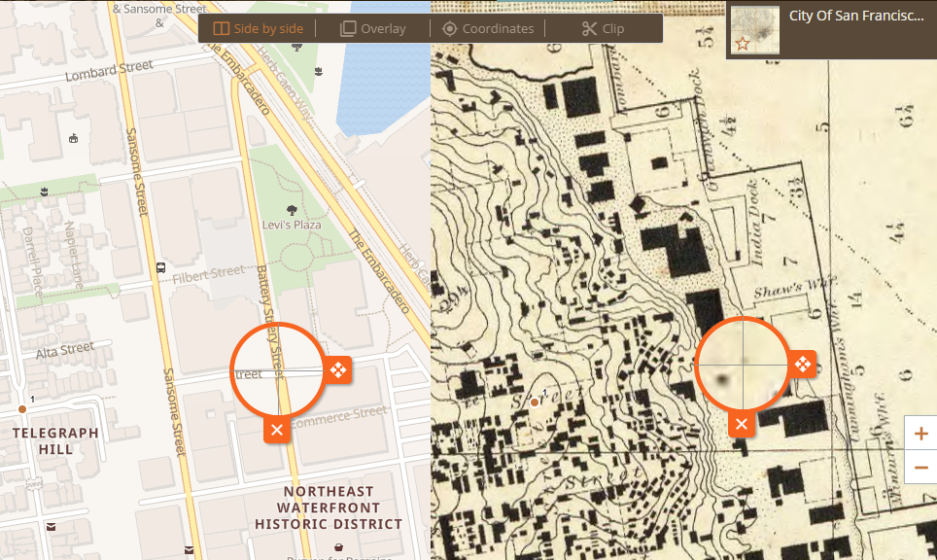

*Creating control points in side-by-side view.*

* If you need to adjust the point’s location, grab the magnifying glass by its right-hand “tab” to drag around the cross hairs within it. For a more fine-tuned placement, you can click and drag the terrain within the circle of the magnifying glass itself. Press ESC at any time to cancel the control point before it is created.
* To finalize the point, either click the checkmark on the edge of the magnifying glass, or if the check does not appear, click off of the point you just placed.
* To delete the control point, click the X on the edge of the magnifying glass.
* Right now, place four control points in four different areas of your map before moving on.

*3.2 - Best Practices for Creating Control Points*

* The quality of your georeferencing job depends on the quality of your control points! Thus, you should only place a point if you are quite confident that the two locations actually correspond to one another in physical space, and that any landmarks you are using have not changed since the time of the map’s creation.
* Great places for control points: road intersections, right-angles of administrative boundaries (assuming they haven’t changed over time!), mountain peak markers
* Unreliable places for control points: edges of bodies of water and vegetation (these change on human timescales), buildings (unless you’re positive they are unchanged)
* It’s a good idea to place four control points in a “bounding box” around the map extent you are interested in, to ensure your area of interest falling inside them is not excluded from the warp.
* Add more points where greater distortion is expected, like mountains and (especially in historical maps) coastlines.

*3.3 - Tweaking your edits in Overlay view*

* Click the “Overlay” button in the top bar of the Georeference window. You should now see your map image laid over the modern basemap. To change the opacity of the map image, use the slider in the top-right of the frame.
* To toggle the visibility of your map image off and on, press the SHIFT key. Flashing back and forth between the old and modern maps with SHIFT is a good method for finding areas where cities, landforms etc. are misaligned and need further control points.

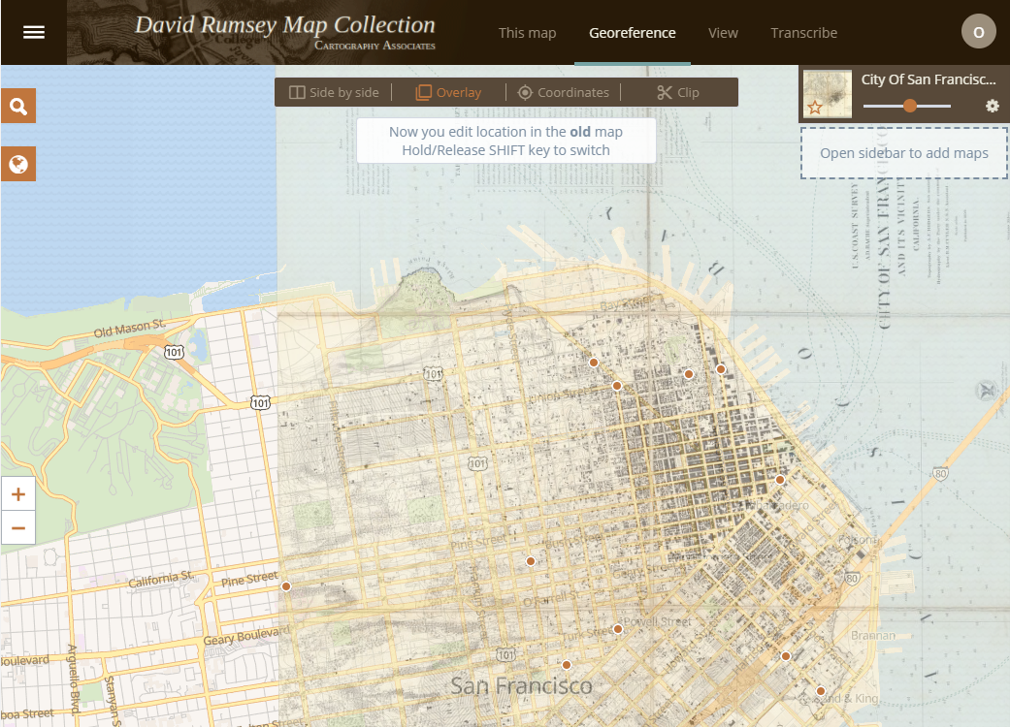

*Overlay view. Transparency slider (top right) is set at ~50%.*

* If you wish to place additional control points in Overlay view, zoom/pan to the region you want to georeference. Click to place the control point in the proper location on the *old map first.* The old map will then temporarily “vanish”, leaving you to place the next control point on the *basemap*. (You can still zoom and pan around the basemap, if necessary, before placing the control location.) Press Esc at any time to cancel the control point before it is created.

*3.4 [Optional] - Checking Accuracy in Coordinates View*

* You may notice that the locations you “pinned together” may not exactly overlap in Overlay view. This is because Georeferencer warps your image using a “best fit” alignment with the control points you have defined, attempting to evenly distribute any error amongst all of the points.
* Click on the “Coordinates” button in the top bar while in Georeference mode. Coordinates View displays a table of the (X,Y) control point locations you have placed so far. The *Error* column shows the distance, in pixels, between the point on the old map vs the point on the new map. As you mouse over a row in the table, the corresponding control point will highlight in blue on the left-hand map image.
* Some rows/points may appear in red--these are control points that have significantly higher error than the others, and may be warping the map excessively. As you fine-tune your map, you may choose to focus on improving the accuracy of these red control points first.

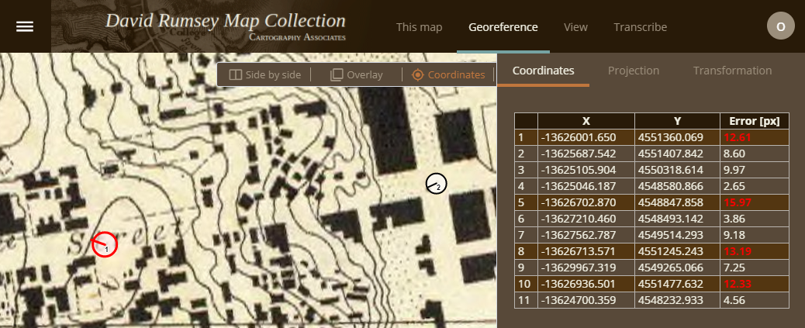

*Fig 4: Coordinates View. Points with relatively higher error are highlighted in red on the left-hand map view.*

*3.5 - Clipping the extent of your map image*

Many of the images on DavidRumsey.com contain additional (sometimes non-cartographic) content that you may choose to exclude from the final, georeferenced product: for example, empty margins of scanned sheets, body text from an atlas page, an inset map of a city, etc. You can define the extent of the actual map in the image by using the Clip feature (click the *Clip* button in the top bar of the Georeference window).

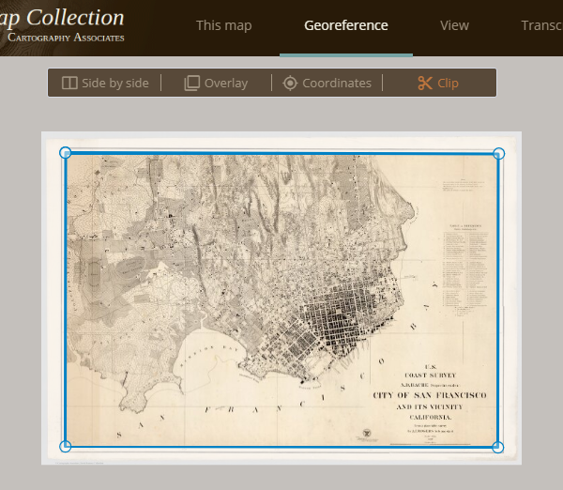

Click and drag the vertices of the blue bounding box to only include your map content. To add a new, additional vertex, simply click and drag from one of the existing blue lines. Zoom and pan features work as normal in Clip view.

**4 - When is my georeferencing “done”?**

After you place four or more control points, a message at the bottom right of the georeference window will automatically read “It looks like this map is finished”, *regardless of the accuracy of your georeferencing*. Whether or not your georeferencing is “complete” is a somewhat subjective decision--your ultimate goal is to (a) create as much visual agreement as possible between the old map and the basemap, and (b) reduce the amount of error in your control points as much as is feasible.

**5 - Now that I’ve georeferenced my map, what can I do?**

Clicking “Save” in the bottom-right window of Georeferencer will trigger a pop-up offering options for viewing your newly georeferenced map: either “View this map” on its own or “Compare & Overlay” it with others in the collection.

Clicking “Next” in this bottom-right window will take you to a new, random map in Georeference mode--either one that has not been georeferenced or one that only has a few points.

Any site visitor can now link to and include your georeferenced image in web maps they build on sites such as ArcGIS Online, Carto, and MapBox. The image can also be added to a desktop GIS software, such as ArcMap or QGIS. A user can even create new geospatial data by digitizing features from the historical map, such as ancient country boundaries, historical river paths, or points of significant battles. These newly-created data may be combined with contemporary data for any number of different analyses or cartographic projects.